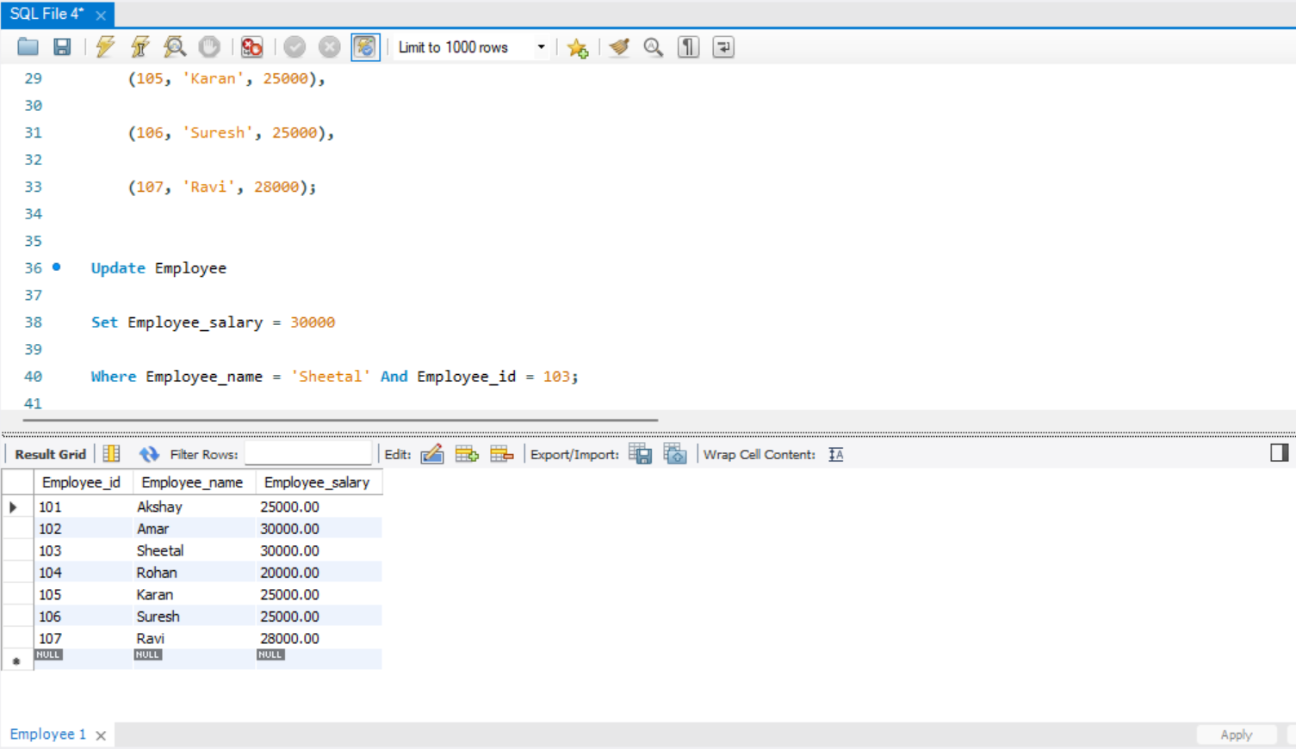

CREATE DATABASE EmployeEsDB;

USE EmployeEsDB;

Create Table Employee (

Employee_id INT PRIMARY KEY,

Employee_name VARCHAR(50),

Employee_salary DECIMAL(10, 2)

);

Insert Into Employee (Employee_id, Employee_name, Employee_salary)

VALUES

(101, 'Akshay', 25000),

(102, 'Amar', 30000),

(103, 'Sheetal', 28000),

(104, 'Rohan', 20000),

(105, 'Karan', 25000),

(106, 'Suresh', 25000),

(107, 'Ravi', 28000);

Update Employee

Set Employee_salary = 30000

Where Employee_name = 'Sheetal' And Employee_id = 103;

Select * From Employee;

Select *

From Employee

Select *

From Employee

Order by Employee_salary Asc;

Select *

From Employee

order by Employee_salary Desc;